**NAME:Ayush Vinod Upadhyay**

**EXPERIMENT NO. 11**

**CO/LO: CO1-Develop web applications.**

**CO2- Work effectively as a member of a team.**

**AIM / OBJECTIVE:** **Mini-Project**

**PROBLEM STATEMENT:**

Create an app/web application for vendors to upload their goods/products and allow them to sell it along with proper details of the product. Also use database connectivity to store the details of the user on sign-up. The user should also be able to view products of other vendors and trade with them.

**SNAPSHOTS OF PROJECT:**

[**https://shopnest-ayush.netlify.app**](https://shopnest-ayush.netlify.app)

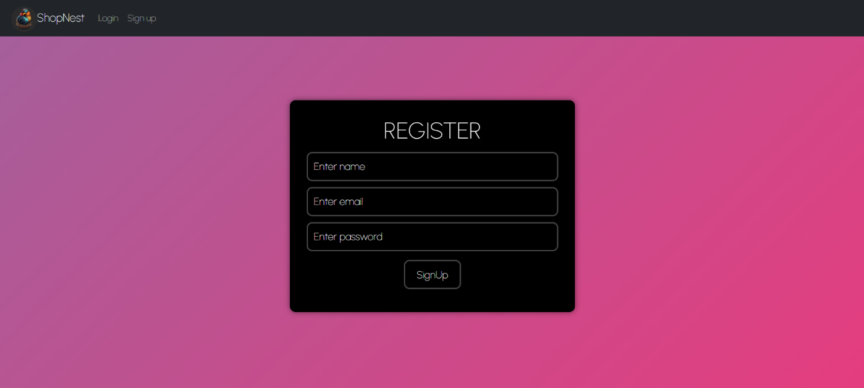

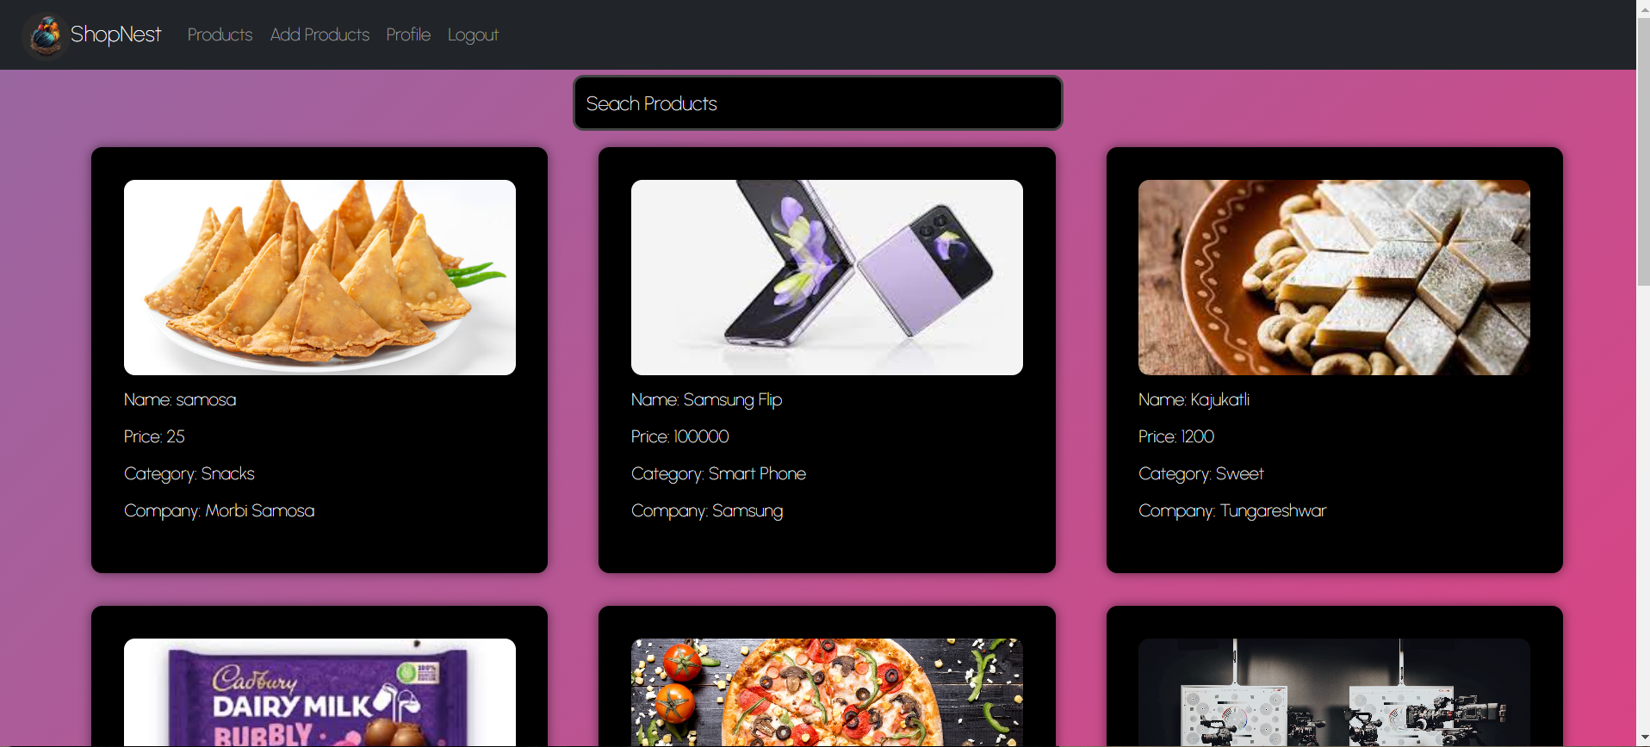

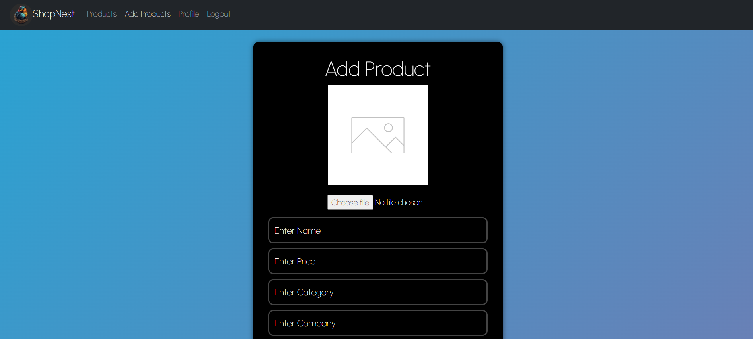

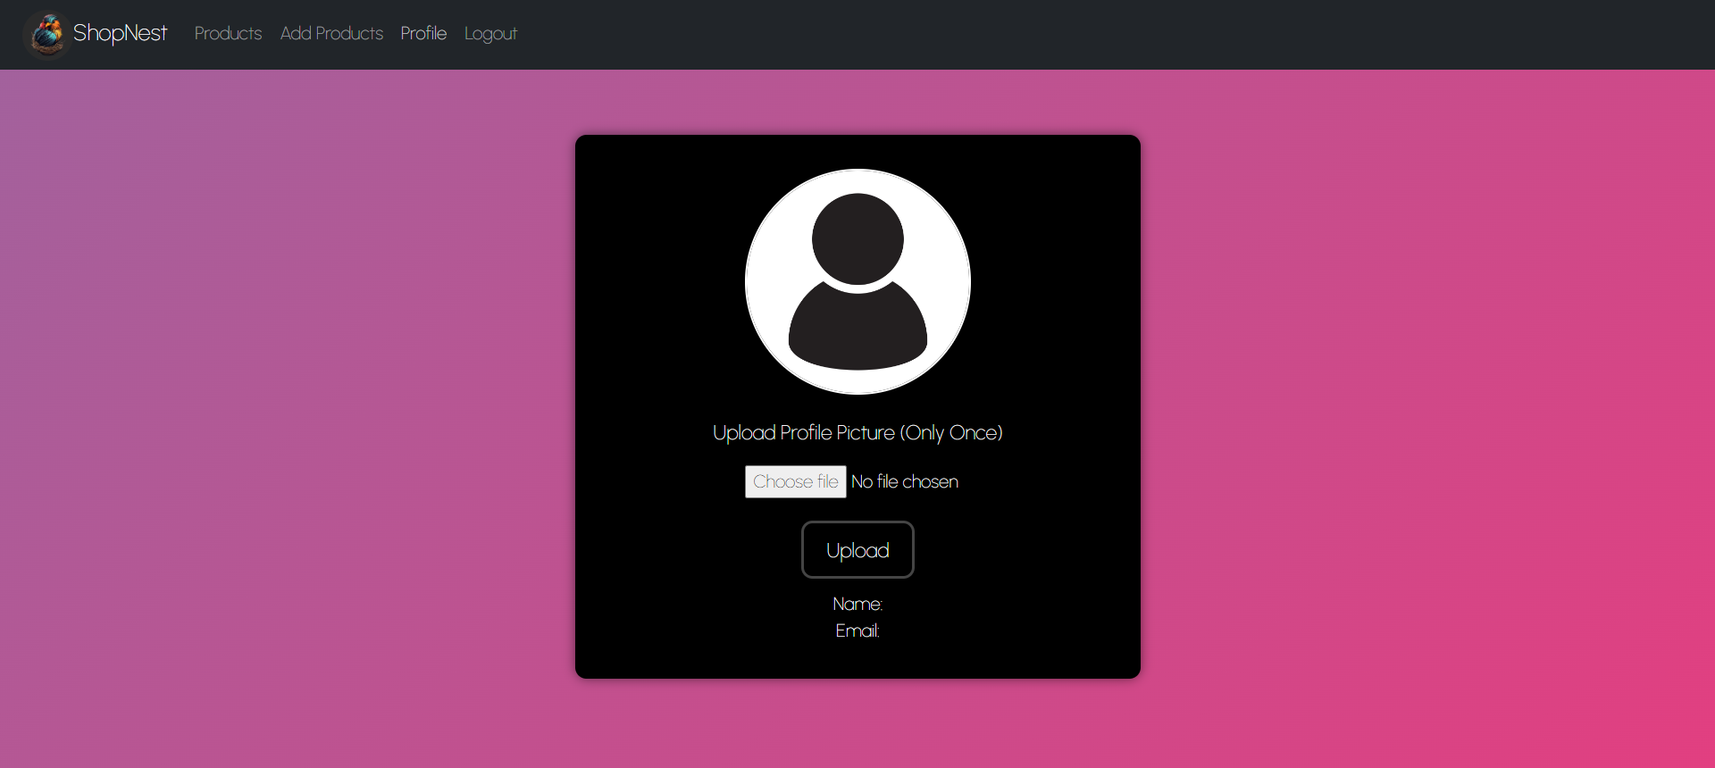

**Github Link of the project:**

<https://github.com/Ayush-865/ShopNest-Backend>

<https://github.com/Ayush-865/ShopNest>